**Each group should two of the problems below to implement using solver in spreadsheet**

**submit to:*pkisambira@ucu.ac.ug***

**Linear programming questions**

1. **Product Mix Problem**

Formulate a linear programming model for this problem, to determine how many containers of each product to produce tomorrow in order to maximize the profits. The company makes four types of juice using orange, grapefruit, and pineapple. The following table shows the price and cost per quart of juice (one container of juice) as well as the number of kilograms of fruits required to produce one quart of juice.

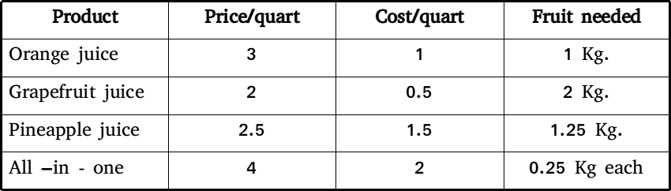

On hand there are 400 Kg of orange, 300 Kg. of grapefruit, and 200 Kg. of pineapples. The manager wants grapefruit juice to be used for no more than 30 percent of the number of containers produced. He wants the ratio of the number of containers of orange juice to the number of containers of pineapples juice to be at least 7 to 5. pineapples juice should not exceed one-third of the total product.

1. **Diet problem**

My diet requires that all the food I eat come from one of the four “basic food groups” (chocolate cake, ice cream, soda, and cheesecake). At present, the following four foods are available for consumption: brownies, chocolate ice cream, cola, and pineapple cheesecake. Each brownie costs 50 cents, each scoop of chocolate ice cream costs 20 cents, each bottle of cola costs 30 cents, and each piece of pineapple cheesecake costs 80 cents. Each day, I must ingest at least 500 calories, 6 oz of chocolate, 10 oz of sugar, and 8 oz of fat. The nutritional content per unit of each food is shown in the following table. Formulate a linear programming model that can be used to satisfy my daily nutritional requirements at minimum costs.

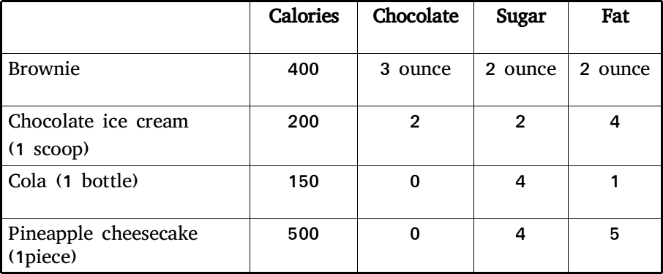

1. **Blending problem**

The Low Knock Oil company produces two grades of cut rate gasoline for industrial distribution. The grades, regular and economy, are produced by refining a blend of two types of crude oil, type X100 and type X220. each crude oil differs not only in cost per barrel, but in composition as well. The accompanying table indicates the percentage of crucial ingredients found in each of the crude oils and the cost per barrel for each. Weekly demand for regular grade of Low Knock gasoline is at least 25000 barrels, while demand for the economy is at least 32000 barrels per week. At least 45% of each barrel of regular must be ingredient A. At most 50% of each barrel of economy should contain ingredient B. the Low Knock management must decide how many barrels of each type of crude oil to buy each week for blending to satisfy demand at minimum cost .

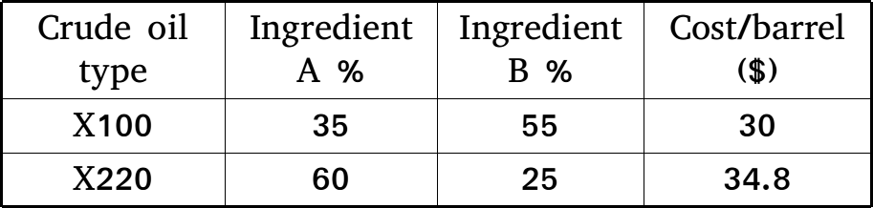

**4 Media selection problem**

A company has budgeted up to $8000 per week for local advertisement. The money is to be allocated among four promotional media: TV spots, newspaper ads, and two types of radio advertisements. The company goal is to reach the largest possible high-potential audience through the various media. The following table presents the number of potential customers reached by making use of advertisement in each of the four media. It also provides the cost per advertisement placed and the maximum number of ads than can be purchased per week.

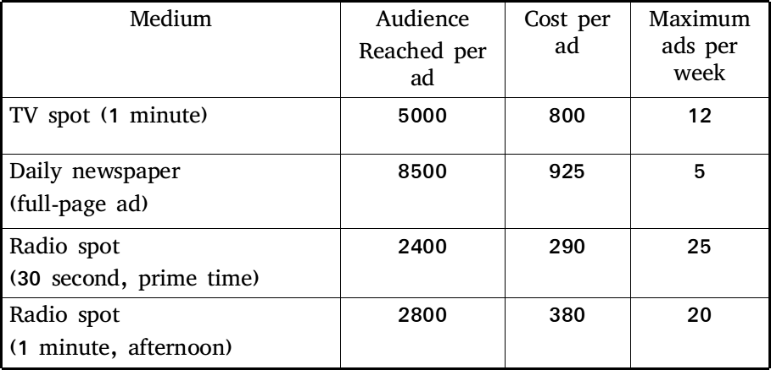

The company arrangements require that at least five radio spots be placed each week. To ensure a board-scoped promotional campaign, management also insists that no more than $1800 be spent on radio advertising every week.

1. **Assignment problem**

A law firm maintains a large staff of young attorneys who hold the title of junior partner. The firm concerned with the effective utilization of this personnel resources, seeks some objective means of making lawyer-to-client assignments. On march 1, four new clients seeking legal assistance came to the firm. While the current staff is overloaded, the firm needs to identify four junior partners who, although busy, could possibly be assigned to the cases. Each young lawyer can handle at most one new client. Furthermore each lawyer differs in skills and specialty interests.

Seeking to maximize the overall effectiveness of the new client assignment, the firm draws up the following table, in which it rates the estimated effectiveness (of a scale 1 to 9) of each lawyer on each new case.

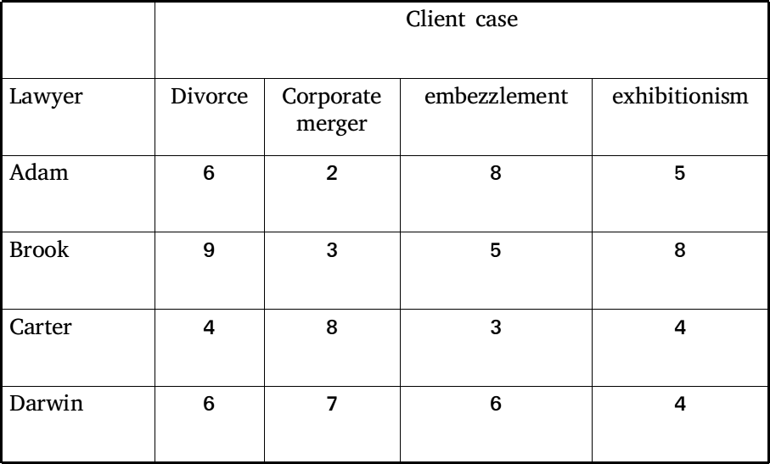

**6. Transportation problem**

The Top Speed Bicycle Co. manufactures and markets a line of 10-speed bicycles nationwide. The firm has final assembly plants in two cities in which labor costs are low, New Orleans and Omaha. Its three major warehouses are located near the larger market areas of New York, Chicago, and Los Angeles.

The sales requirements for next year at the New York warehouse are 10000 bicycles, at the Chicago warehouse 8000 bicycles, and at the Los Angeles warehouse 15000 bicycles. The factory capacity at each location is limited. New Orleans can assemble and ship 20000 bicycles; the Omaha plant can produce 15000 bicycles per year. The cost of shipping one bicycle from each factory to each warehouse differs, and these unit shipping costs are:

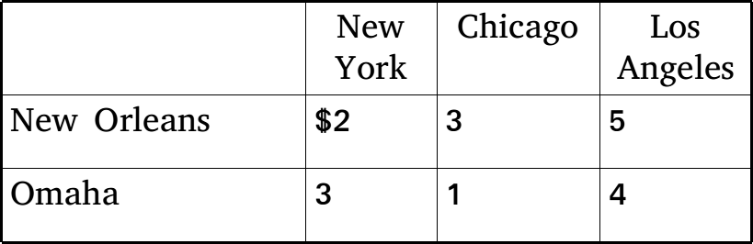

The company wishes to develop a shipping schedule that will minimize its total annual transportation cost

**7. Portfolio selection**

The International City Trust (ICT) invests in short-term trade credits, corporate bonds, gold stocks, and construction loans. To encourage a diversified portfolio, the board of directors has placed limits on the amount that can be committed to any one type of investment. The ICT has $5 million available for immediate investment and wishes to do two things: (1) maximize the interest earned on the investments made over the next six months, and (2) satisfy the diversification requirements as set by the board of directors. The specifics of the investment possibilities are:

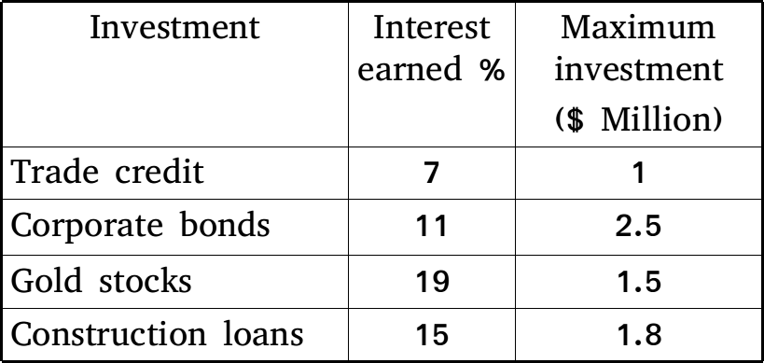

In addition, the board specifies that at least 55% of the funds invested must be in gold stocks and construction loans, and that no less than 15% be invested in trade credit.